University of Wah
Department of Computer Science
BS Cyber Security
Human Computer Interaction & Computer Graphics
Project Report

Title: User-Centered Redesign of a GPA & CGPA Calculation System
Submitted to: Ma’am Masra Riaz
Group Members:
Aqsa Shehzadi (UW-23-CY-BS-021)
Ibrar Ul Hassan Shami (UW-23-CY-BS-018)
Section: BS-CYS-5N
Table of Contents
1 Introduction: 1
2 Problem Concept: 1
2.1 Problem Statement: 1
2.2 Solution we have Proposed: 2
2.3 Targeted Users: 2
3 Existing System Analysis: 3
3.1 Purpose of Analysis: 3
3.2 Selected Systems for Analysis: 3
3.2.1 Analysis of Scholaro GPA Calculator: 3
3.2.2 Analysis of GPAcalculator.net: 4
3.2.3 Analysis of Calculator.net GPA Calculator: 4
3.2.4 Analysis of University of Education GPA Calculator (Local System): 4
3.3 Summary of Identified Usability Issues: 5
4 Pact Analysis: 5
4.1 People: 5
4.2 Activities: 5
4.3 Context: 6
4.4 Technologies: 6
5 User Research: 6
5.1 Research Objective: 6
5.2 Research Method: 7
5.3 Interview Participation Criteria: 7
5.4 Interview Script: 8
5.4.1 Core Interview Questions and Follow Ups Questions: 8
5.4.2 Conclusion Script: 11
5.4.3 Research Findings: 11
6 User Modeling: 13
6.1 Persona 1: Local GPA-Focused Student 13
6.2 Persona 2: Student Looking to Study Abroad 14
6.3 Usage Scenarios: 16
6.4 User Goals & Key Tasks: 17
7 Design Development: 17
7.1 Design Requirements: 17
7.2 Functional Requirements: 18
7.3 Non-Functional (Usability) Requirements: 20
7.4 Low-Fidelity Design (Sketching Phase) 20
7.5 Digital Prototype Development: 24
7.5.1 High-Level Navigation Structure: 25
7.5.2 GPA Calculation Interface: 25
7.5.3 CGPA Calculation Interface: 26
7.5.4 Learning and Explanation Interfaces: 26
7.6 Cognitive Load Reduction Strategies: 27
8 Design Prototype: 27
8.1 Welcome Page: 27
8.2 GPA Calculator: 28
8.3 CGPA Calculator: 28
8.4 Credit Hours Explained: 29
8.5 GPA & CGPA Calculation Explained: 30
8.6 International GPA Interpretation: 31
9 Website: 32

Introduction:
Human Computer Interaction (HCI) is related to designing systems that are interactive meaning that their priority is providing high efficiency, effectiveness, accuracy and provide satisfaction to the users. Many systems failed not because they don’t have the necessary functionality but because they are poorly designed. They present information unclear and lack do not fulfill the user needs.
In academic environments GPA & CGPA Calculation Systems are the most widely used by students and teachers alike to evaluate their performance but the thing is most of these systems are poorly designed, they only provide the final results and do not even explain the calculation process. This causes confusion, especially among first-year students and those applying for applying for higher studies
Our Project aims to redesign the existing GPA & CGPA Calculation Systems using an HCI focused approach, focusing on our user’s needs and requirements. The redesign will focus on providing clarity and explanation and displaying only necessary information. We have also incorporated a Novelty Feature in which the users can convert their local/national GPA & CGPA into an International criterion, helping users planning to go abroad for higher studies evaluate themselves better.

Problem Concept:

Problem Statement:
Most students fail to understand how GPA is calculated and they often have difficulty interpreting their results and most of the time get them wrong because they do not understand the GPA & CGPA calculation procedure due to poorly designed interfaces leading to incorrect input and hence the wrong results. This causes distrust in the academic systems and high anxiety for the users which can cause dissatisfaction.
“The problem lies not in the calculation process itself, but the way the information is presented to the users and how they interact with it in the correct manner or not.”

Solution we have Proposed:
The system we are designing is User Focused and designed with HCI principles in mind to improve the understanding and usability for the students who want to calculate their GPA & CGPA. For this approach the system will do the following:
- Provide clear explanations & breakdowns of Grades and Credit Hours and what is their role in the calculation process
- Provides step-by-step explanations of GPA & CGPA Calculations so Students can truly understand what’s happening
- Reduces cognitive load during stressful result periods
- Provides the user with the Formulas and Dummy background data to prevent incorrect results
Novelty Feature:
We have introduced a Novelty Feature for calculation of GPA & CGPA with respect to international standards as well. This will help students understand how their GPA & CGPA is calculated in abroad and how they will be evaluated. This feature in introduced to help students who are thinking of studying abroad and are concerned on how they’ll be evaluated in foreign Universities.

Targeted Users:
Primary Users:
- Undergraduates
- First-year students
Secondary Users:
- Students planning to study abroad for higher education
- Professors, Teaching Assistants & Academic Advisors

Existing System Analysis:

Purpose of Analysis:
This analysis was performed in order to identify, highlight & understand common issues within the design of these websites & usability issues that weren’t addresses properly. This analysis will be helpful in understanding why students are frustrated with the current systems.

Selected Systems for Analysis:
The following 4 systems are selected for Usability Analysis because of their popularity & relevance to our HCI Project:
- Scholaro GPA Calculator
- GPAcalculator.net
- Calculator.net GPA Calculator
- University of Education GPA Calculator

Analysis of Scholaro GPA Calculator:
Usability Issues Identifies:
- For International GPA conversion students need to understand complex conversion standards manually which can lead to high cognitive load
- The interfaced shows the user with too much input fields at once which can lead to high cognitive load in users.
- The system’s explanation of the final results are often non-existent.
- Users may have difficulty understanding whether they have entered correct information or not
HCI Impact:
- It induces high cognitive load
- Limited to no Transparency
- New users cannot learn the systems easily

Analysis of GPAcalculator.net:
Usability Issues Identifies:
- It already assumes that the user knows everything
- The system doesn’t explain how Credit Hours affect your final GPA
- Error prevention is weak, allowing incorrect inputs without warnings which in turn leads to inconsistent results.
HCI Impact:
- New users can find it difficult to learn
- No Feedback mechanisms are designed
- Higher chances of errors from the user’s side

Analysis of Calculator.net GPA Calculator:
Usability Issues Identifies:
- This system lacks personalization options
- Meaning this system doesn’t support (what if) scenarios, what-if student only want CGPA of 4 semesters
- This interface doesn’t focus making the user comprehend anything, it just gives output
- Results are outputted without explanation
HCI Impact:
- The user engagement is quite low
- There is no Support for decision-making

Analysis of University of Education GPA Calculator (Local System):
Usability Issues Identifies:
- No guidance is provided for incorrect inputs
- This System assumes the users knows it all
- Too much text is displayed causing cognitive load in users
- No breakdown or explanations of results

HCI Impact:
- The Accessibility is Poor
- High cognitive effort is placed on the user
- Users may suffer from high Anxiety

Summary of Identified Usability Issues:
This analysis says so much about the design flaws within the existing GPA & CGPA Calculation Systems that include poor learnability, poor transparency, high cognitive load and poor error handling. Most of these systems just give the final result and fail to make the students understand how the process actually happened. These issues highlight the need for a new User-Focused GPA & CGPA Calculation Systems that can fix these issues.

Pact Analysis:

People:
- Students of University ages ranging from 18 to 25
- Different students have different levels of academic knowledge
- Some students have an experience of high stress during result announcements
- Some students may have accessibility needs

Activities:
- Inputting grades and credit hours in order calculate their GPA
- Calculating GPA
- Calculating CGPA
- Exploring GPA & CGPA interpretation under different international grading systems

Context:
Physical Context:
- Mostly used via on Mobile Phones, Laptops and Tablets
- Often accessed during short breaks or late nights
Social Context:
- Most of the students use these calculators in private
- Sometimes they use it with peers for comparison or discussions on improvement
Organizational Context:
- Local grading policies of Home Country
- Different criteria of grading utilized by abroad countries like Germany used an inverted scale and UK using the Class System
Environmental Context:
- After the announcements of Final grade

Technologies:
- Website for both Desktop and Mobile Phones
- Input methods include Touch on phones and keyboard input via Laptops
- Internet connectivity is a must

User Research:

Research Objective:
The main reason of this research is to understand the expectations, experiences and expectations of the students when they are using a GPA & CGPA Calculation System. The aim of this research is to understand student’s understanding and concerns regarding GPA interpretation across different countries.

Research Method:
Our method adopts a qualitative approach that is:
- Participants: 15 to 20 Undergraduate University Students were chosen for this interview
- Method: 1 on 1 interviews will be conducted in order to extract maximum information
- Duration: It’ll take less than 10 minutes
- Ethical considerations: Participation in the interview in completely voluntary and participant can leave anytime without stating a reason. The data collected will be kept confidential

Interview Participation Criteria:
Since our aim was to understand diverse experiences of GPA & CGPA Calculation from the students we selected participants via careful sampling to ensure that we got the data from a wide range of students.
The primary criteria for participant selection were as follows:
- Academic Level Diversity: Participants from all academic years were selected like mid program students, final years, third years, second years and final years.
- Experience with GPA Calculation Systems: Only the students who has calculated their GPA & CGPA through any means were selected so we can get real world experience data
- Variation in Academic Confidence: Those students were selected who had a lot of experience and those who had very little experience were selected so that usability issues from both sides can be addressed.
- International Study Consideration: Some participants were selected on the bases of whether the wanted to study abroad or not in order to get data for foreign universities.

Interview Script:
Assalam-o-Alikum! my name is Ibrar Ul Hassan Shami and my partner is Aqsa Shehzadi, We are conduction this interview for a project of ours that we need to make for the subject of HCI. The topic of discussion is GPA & CGPA Calculation Systems and we want to know your thoughts on the experiences and challenges you have faced while interpreting your GPA or CGPA
The interview will last less than 10 minutes. I’ll ask you questions on how do you usually calculate your GPA & CGPA currently, what type of tool or methods do you use, do you need assistance in this process and what difficulties do you face? There are no wrong answers and there are no right ones either I just want to hear about your experiences on the topic at hand.
Your participation is on your own free will and discretion and you can leave the interview without stating your reasons at any time during your interview. Responses from all the participants are kept confidential and any of your personal information is not included.

Core Interview Questions and Follow Ups Questions:
- Current GPA Calculation Practice:
Core Question:
How do you usually calculate your GPA/CGPA?
Follow Ups Questions:
- What type tools or methods did you use?
- Why do you prefer this specific method/tool?
- When was the first time you used it?
- Tools and Workflow:
Core Question:
Can you explain the steps you took for the calculation of you GPA/CGPA?
Follow Ups Questions:
- What information did you feed or utilized?
- Which step confused you?
- Did you require assistance from somebody else?

- Pain Points:
Core Question:
Which part of the calculation process did you find the most difficult?
Follow Up Questions:
- Is it the grades or credit hours or the conversion formula?
- Why did you find this part difficult? Elaborate.
- How do you usually deal with this difficulty when you face it? Do you ignore it?
- Errors and Trust:
Core Question:
Did you ever receive a result that was wrong or unclear
Follow Up Questions:
- What made you think/feel it was incorrect/wrong?
- Did you verified the result?
- How did this affect your trust in the current systems?
- Understanding Credit Hours:
Core Question:
Do you understand the role of credit hours in GPA and CGPA Calculation process?
Follow Up Questions:
- When & How did you find about this?
- Did any existing calculators explain this clearly?
- What would need to be changed in order to help you understand it?
- Interpretation of Results:
Core Question:
When you have got the final result. How confident are you that you understand it?
Follow Up Questions:
- Did you compare it with some other result or … How did you find about it?
- Did you feel stressed or satisfied?
- Why?

- International Context:
Core Question:
Have you ever thought of studying abroad?
Follow Up Questions:
- Did their GPA requirements confuse you or not?
- Have you ever tried converting your GPA into their criteria?
- Did you face any challenges?
- Cross-Country GPA Understanding:
Core Question:
Are you well informed on how your GPA is calculated in another country?
Follow Up Questions:
- From where did you get this information?
- What would aid you in understanding that?
- Does having a comparison feature helpful?
- Desired Features:
Core Question:
What features would make a GPA calculator easier to use for you?
Follow Up Questions:
- Step-by-step explanation?
- Visual breakdown?
- International comparison?
- Overall Experience:
Core Question:
If you could make one wish and you could change or add one thing within the current systems, what would it be?
Follow Up Questions:
- Why this change specifically?
- How will it be helpful to you?

Conclusion Script:
Well, that was an exciting interview! I am very grateful for your responses and I have learned a lot from your experiences and it would aid me in creating a better system according to the user’s needs and requirements.
If something comes to you mind or you would like to add anything else, you can reach out to us via xxxx-xxxxxxx. You can also ask for any clarification on questions you didn’t quite get
Will you like to ask any questions before we finish?

Research Findings:
When we made an analysis of the 17 interviews, we took from the undergraduate students some recurring themes occurred. The prominent of them that cased the most issues to the users are listed below:
Theme 1: Heavy Reliance of Online Tools Without Complete Understanding
Most of them said that they used online tools like websites or mobile applications rather than manual calculation but none of them seem to understand the actual process behind the calculation itself but their reliance is also justified due to ease of use.
Key Insight:
Users will always seem to tend towards ease of use over understanding, which may lead to decrease in trust when results are inconsistent.

Theme 2: Confusion About Credit Hours & How are They Important
A huge number of participants said that they did not truly understand the role of Credit Hours in affecting their GPA & CGPA. Many of them said that the role of Credit Hours is not clearly explain in any of the calculators they have used.
Key Insights:
Due to the lack of knowledge the Cognitive Load is increased which can lead to incorrect input from the user.
Theme 3: Distrust Due to Inconsistent Results
Several of the students experienced inconsistent or incorrect results when using more than one calculator and comparing the results with their transcripts. This lead to the decline of trust in existing GPA Calculation Systems.
Key Insight:
Breakdown of the calculations are necessary for building trust in users
Theme 4: Increased Stress Levels During Result Periods
The participants said that they usually calculate GPA right after their final exams. This time if often filled with high stress so usability and clarity should be increased
Key Insight:
Often GPA Calculators are used in periods of high emotional sensitivity.
Theme 5: Limited Understanding of International GPA Evaluation
Many of them were aware of the fact that the GPA Evaluation is different across different countries but none of them understood how their GPA will be interpreted internationally and they never tried to convert their GPA as well. Some of them weren’t even aware of the issue itself and only became aware during the interview itself.
Key Insight:
There is a strong need for an International GPA Calculation System and its explanation as well.
Theme 6: High Demand for Step-by-Step Explanations
Participants consistently requested features such as step-by-step calculation, formula visibility, visual breakdowns, and clear data input mechanisms.
When we asked the participants for step-by-step explanation, formula visibility and breakdowns, all of them strongly agreed.
Key Insight:
Users want to actually learn the process as well not only just calculate their GPA

User Modeling:
User modelling translates research findings into representative user profiles (personas) and realistic usage scenarios. The personas were created based on recurring patterns identified during interviews with undergraduate students.
In user modeling we create personas and realistic scenarios, Personas are like user profile that are created based on recurring patterns found in the interview data and Scenarios are realistic stories which tell how the user profile operates the system.

Persona 1: Local GPA-Focused Student
Personal Profile:
Name: Ali Raza
Age: 20
Semester: 3rd Semester Undergraduate
Program: Bachelors in Cybersecurity
Technical Level: Medium
Device Used: Mostly Phone sometimes Laptop

Background:
Ali Raza checks his GPA after each semester. He is fond of using online tools due to convenience and finds manual calculation difficult. Although he understands that the number of credit hours affect GPA but he doesn’t know how they are applied in the calculation.
Goals:
- He wants to quicky calculate his results
- Doesn’t want incorrect results
Pain Points:
- He is confused about how credit hours affect GPA & CGPA
- He doesn’t want inconsistent results because that effects his confidence
- His trust drops when he sees that his results on his transcript are different
- He doesn’t want lack of explanation
Motivation:
He just wants a tool that he can rely on and that clearly explains how his GPA & CGPA is calculated so his anxiety levels don’t touch the roof.

Persona 2: Student Looking to Study Abroad
Personal Profile:
Name: Noor Fatima
Age: 21
Semester: 5th Semester Undergraduate
Program: Bachelors in Cybersecurity
Technical Level: Medium
Device Used: Mostly Phone sometimes Laptop

Background:
Fatima is actively looking for universities to study abroad. She calculates her CGPA to check if she is eligible to apply or not. She does know that internationally different countries follow different criteria but she doesn’t clearly understand how her CGPA is going to be evaluated Internationally.
Goals:
- She wants to accurately calculate her CGPA
- She wants to compare here result with international criteria on the go
- She wants to know how her GPA is interpreted in different countries
Pain Points:
- She wants a single tool for international GPA interpretation
- She has anxiety due to lack of transparency
- She is overwhelmed by the confusing international standards
- She is also confused by their eligibility criteria
Motivation:
Fatima wants a tool that can not only calculate her GPA & CGPA but also convert it into international standard so she can evaluate her performance.

Usage Scenarios:
Scenario 1: Calculating Semester GPA (Ali Raza)
Today was Ali’s result and now he wants to calculate his GPA. He opens an Online tool on his phone to calculate his grade and the calculator asks for grades and credit hours but it doesn’t explain how the credit hours effected his GPA. When he used another calculator, he gets a different result. This makes him doubt the accuracy of his own calculated results
He thinks that what if there was a system/calculator the provided him with step-by-step explanations how the GPA was calculated and what role his Credit Hours played. He wants the correct result on the first try he doesn’t have to cross check on various other websites
Scenario 2: Understanding International GPA Evaluation (Noor Fatima)
Fatima is busy in preparing her documents for her abroad journey. She calculated her CGPA using an online tool but she doesn’t know how here GPA will be interpreted in international universities. She searched for online tools and finds tools that require complex calculations, she feels disheartened and burnout due to her increased cognitive load.
She wished that she would just have to enter her CGPA and choose her desired country and the tool gives her complete detail on how here GPA is going to be evaluated with clear explanations. This reduced her cognitive load making her able to take good decisions

User Goals & Key Tasks:
User Goals:
- Accurate calculation of GPA & CGPA
- Trust in the calculator they are using
- Ability to interpret results for international and local grading criterion
- Role of Credit Hours should be comprehendible
Key User Tasks:
- Understand step-by-step explanations
- Input Grades and Credit Hours
- Compare their Local Grade with an International Grade
- Ability to Choose a country to interpret their results

Design Development:
In this phase we’ll convert all the insights gathered from the all the data that has been collected into an HCI focused design. The design will focus on user need and requirements identifies during the interviews. We will have a strong emphasis on reducing cognitive load, improving learnability and transparency.

Design Requirements:
The following requirements were extracted directly from the interview data, personas and scenarios extracted:

Primary Design Requirements:
- Our system will reduce student’s confusion related to credit hours and how they are used
- The system will not just give the final GPA & CGPA but it’ll also make the user clearly understand how it got that result.
- Our system will have 5 toggles/buttons what will help the user get what they want, how they want and when they want
- Our system will have step-by-step processes
- The interfaced will be deisgned in such a way that even a novice could understand it.
- The system will give support for international GPA & CGPA conversion on the go with explanation in order to help student interpret their results better

Functional Requirements:
These describe what our system should do.
FR-1: GPA Calculation
- Ask the user for how many subjects they are studying this semester.
- Generate input fields for the entered subjects and ask students to enter their grades and credit hours
- Display the formula clearly so that the students are aware of the calculation process
- Allow students to calculate their semester GPA with also displaying percentages and explanations etc.
- Allow students to see and evaluate their GPA in an international standard with explanations and providing suggestions
FR-2: CGPA Calculation
- Ask the students to enter the number of semesters
- Generate input fields for the entered subjects and ask students to enter their semester GPAs and Total Credit Hours for that semester
- Display the formula clearly so that the students are aware of the calculation process
- Allow students to calculate their semester GPA with also displaying percentages and explanations etc.
- Allow students to see and evaluate their CGPA in an international standard with explanations and providing suggestions

FR-3: Step-by-Step Breakdown
- Display the formula for GPA and CGPA calculation.
- Display how each subject and its credit hours contributed to the final GPA.
- Provide percentages instead of grades where possible.
- Present calculation steps in a structured and readable format.
FR-4: Error Prevention
- Our system will prevent wrong or invalid grade or credit hour entry from the student.
- It offers Visual guidance when an error occurs
- Our system will allow users to reset inputs without setting everything else up again.
- It’ll provide clear warnings for incomplete & incorrect input.
FR-5: International GPA Interpretation (Novel Feature)
- Our system will allow students to convert their GPA & CGPA into an international grading policy in order to interpret their results.
- It’ll ask the students to select a desired country with a different grading system.
- The system will output interpreted GPA & CGPA alongside local GPA & CGPA for comparison with explanations and suggestions.
- Our system will provide short explanations showing the differences between local and international grading systems/policies.

Non-Functional (Usability) Requirements:
These describe how the system should behave.
Usability Requirements:
- Immediate feedback will be provided to the students leading to a meaningful interaction.
- The navigation and theme and coloring scheme should be consistent throughout all the modules of the system.
- The system should always ask the students about what they want, how they want it and when they want it.
- The system will greatly reduce cognitive load by only displaying and necessary and required information for the interaction
- The interfaced should be so simple and easy to learn that even a novice mid program student can learn it within 5 to 10 minutes
Accessibility Requirements:
- The website should use a simple and non-technical tone of language
- This style would make the explanations simple and easy to understand even for a new user.
- The website should also offer short and concise explanation during the calculation process as well.
- We would ensure that the interface is both Desktop and Mobile friendly
- Clear font styles and sizing should be used to make the website environment friendly

Low-Fidelity Design (Sketching Phase)
Before we start building the website we thought it would be helpful if we created some sketches of how we want to build our design so that it is easy to make changes if we mess up. Here we will quicky check and validate our ideas and choose one that suits the student’s needs the most.
The sketches that are listed below are just made in order to get the idea they in no way represent the aesthetics of the website.
Sketch 1: (Aqsa)
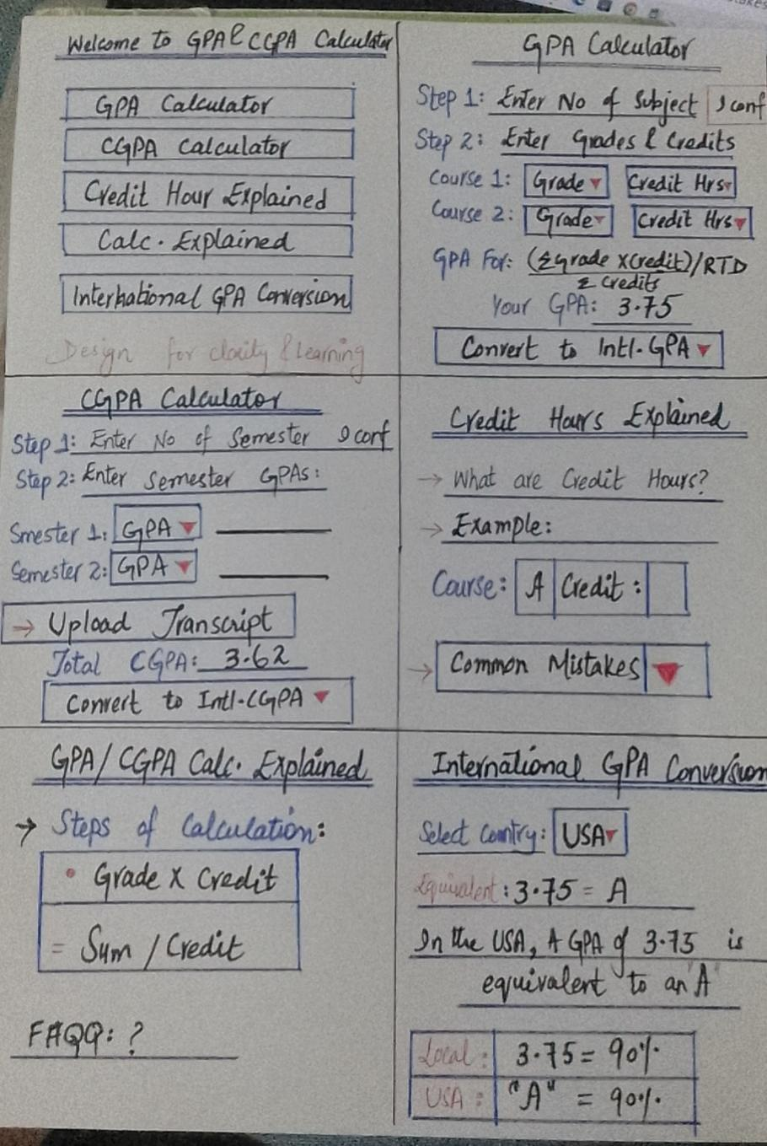
Sketch 2: (Ibrar)
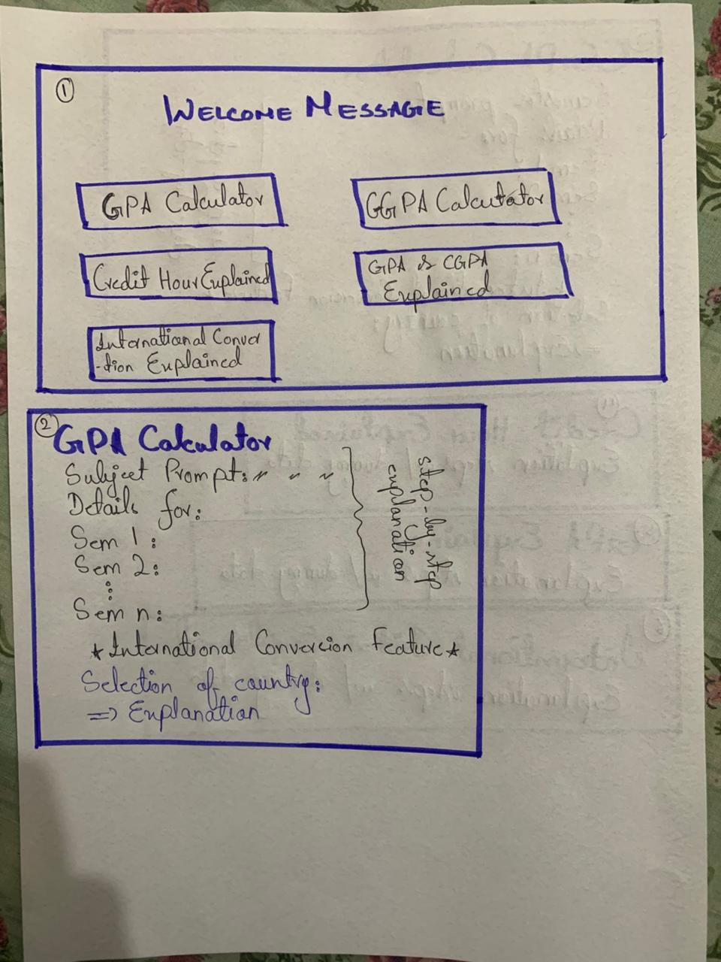

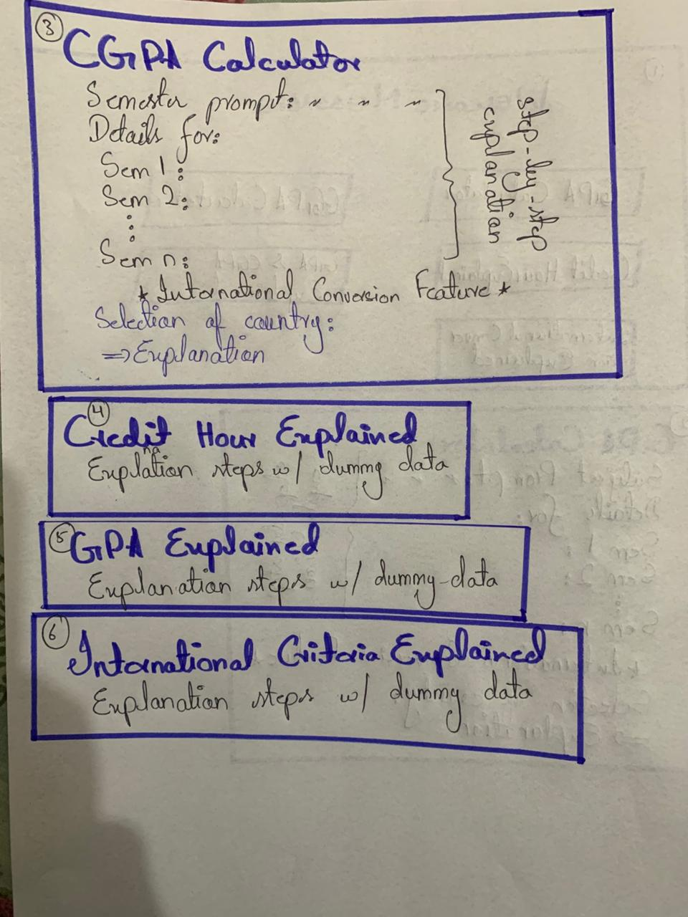
Purpose of Low-Fidelity Sketches:
- To validate our design before designing the digital prototype
- To find which elements are missing early on
- To visually see where buttons should be placed etc.
- To explore the different ways in which we can reduce the cognitive load
Key Screens Sketched:
- Welcome and task selection screen
- GPA Calculation Screen
- CGPA Calculation Screen
- Credit Hour explanation Screen
- Local GPA Explanation Screen
- International GPA Explanation Screen
Photographs of the rough sketches are documented and included to demonstrate the design process.

Digital Prototype Development:
After deciding what we want to design and how we want to design it, we moved towards digital prototyping, which will be developed on Figma. The prototype will be basis of the final website creation. The prototype’s design will also be a task based interactive approach as stated in the sketches above.

High-Level Navigation Structure:
When the system loads the students are greeted with a welcome screen representing the Home Page, it will present the following options:
- GPA Calculator
- CGPA Calculator
- Credit Hours Explained
- GPA/CGPA Explained
- International GPA/CGPA Explained
This structure will allow the students to have a task-based approach reducing extra clutter and also lowering the cognitive load of the students.

GPA Calculation Interface:
The GPA calculation module is designed to promote transparency and user understanding.
Key Features:
- Ask the user for how many subjects they are studying this semester.
- Generate input fields for the entered subjects and ask students to enter their grades and credit hours
- Display the formula clearly so that the students are aware of the calculation process
- Allow students to calculate their semester GPA with also displaying percentages and explanations etc.
- Allow students to see and evaluate their GPA in an international standard with explanations and providing suggestions

CGPA Calculation Interface:
The CGPA module extends the GPA calculation functionality to multiple semesters.
Key Features:
- Ask the students to enter the number of semesters
- Generate input fields for the entered subjects and ask students to enter their semester GPAs and Total Credit Hours for that semester
- Display the formula clearly so that the students are aware of the calculation process
- Allow students to calculate their semester GPA with also displaying percentages etc.
- Allow students to see and evaluate their CGPA in an international standard with explanations and providing suggestions

Learning and Explanation Interfaces:
To support learnability, separate informational modules were included:
Credit Hours Explained:
- Provide step-by-step explanations
- Provide Examples with dummy data
- Highlight common issues
GPA/CGPA Calculation Explained:
- Provide the explanation of Formula
- Provide the complete percentage to grade criteria
- Provide Examples with dummy data
- Show how quality points are calculated with explanations
International GPA/CGPA Calculation Explained:
- Answer the WHY behind the existence of different grading systems
- Explanation of different criterion
- Examples and Explanations
All of these sections are designed in such a way that they reduce the clutter of the website, only provide the necessary information, keeps the interaction task driven and reduce cognitive overload

Cognitive Load Reduction Strategies:
We employed the following strategies to reduce the amount of cognitive load within our design:
- We have used a Task Based Approach, Displaying only necessary options.
- This keeps the information minimal and only accessible to the specific section.
- These is clear separation of the calculation sections and explanation sections although calculation sections have short, clear and concise explanations.
- Always giving the control in the hand of the user by asking questions and then generating the needed response.
- Clear and explicit guidance has been provided to the user in order to significantly reduce and prevent errors via Error Handling Mechanisms.
These points help us in creating a design that can enjoyed by both advanced and novice users alike.

Design Prototype:

Welcome Page:
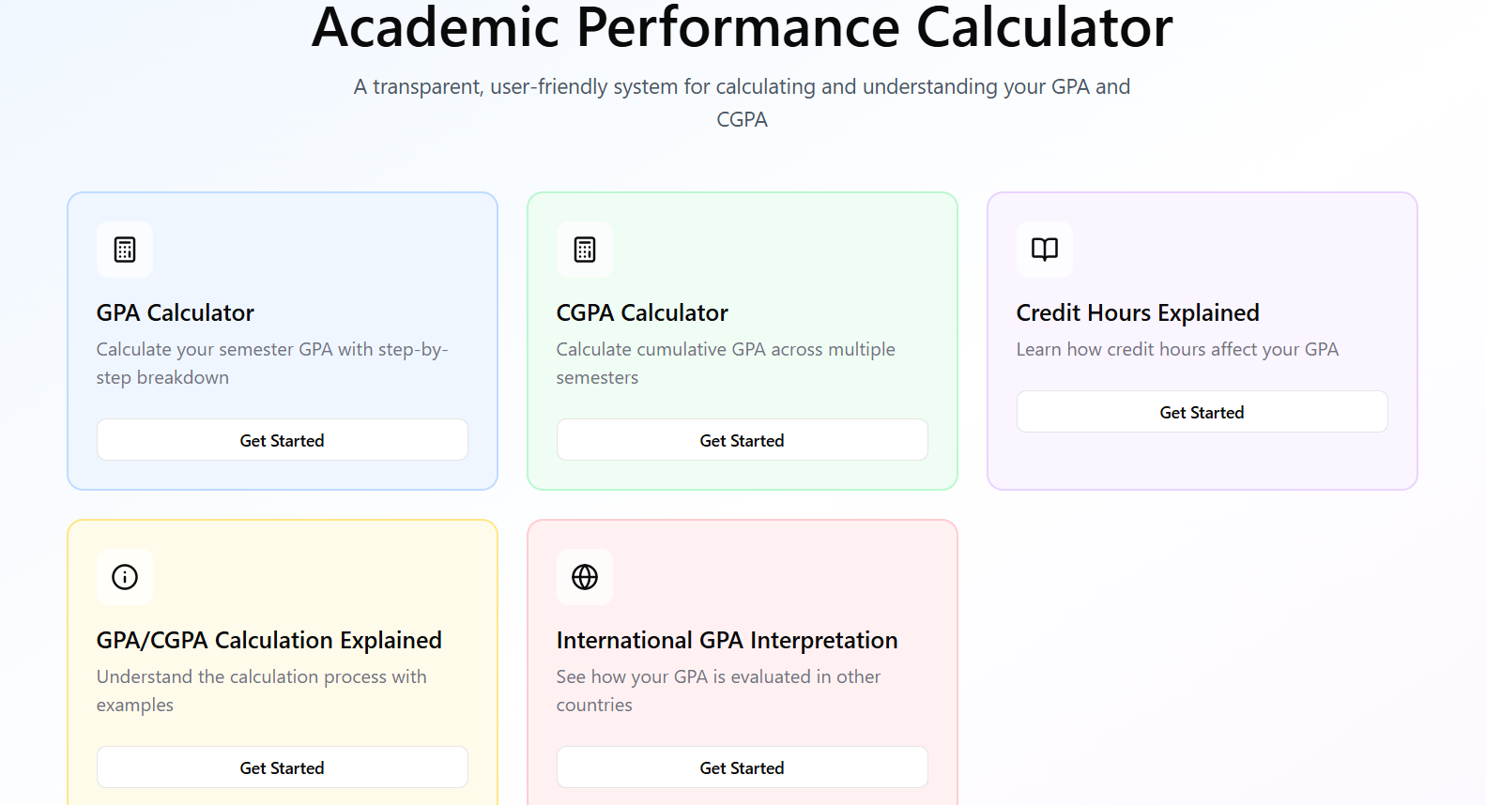

GPA Calculator:
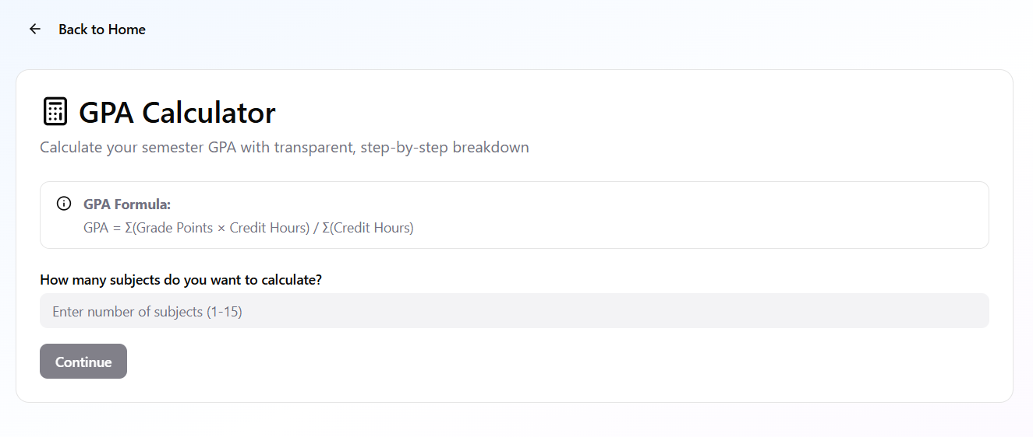

CGPA Calculator:
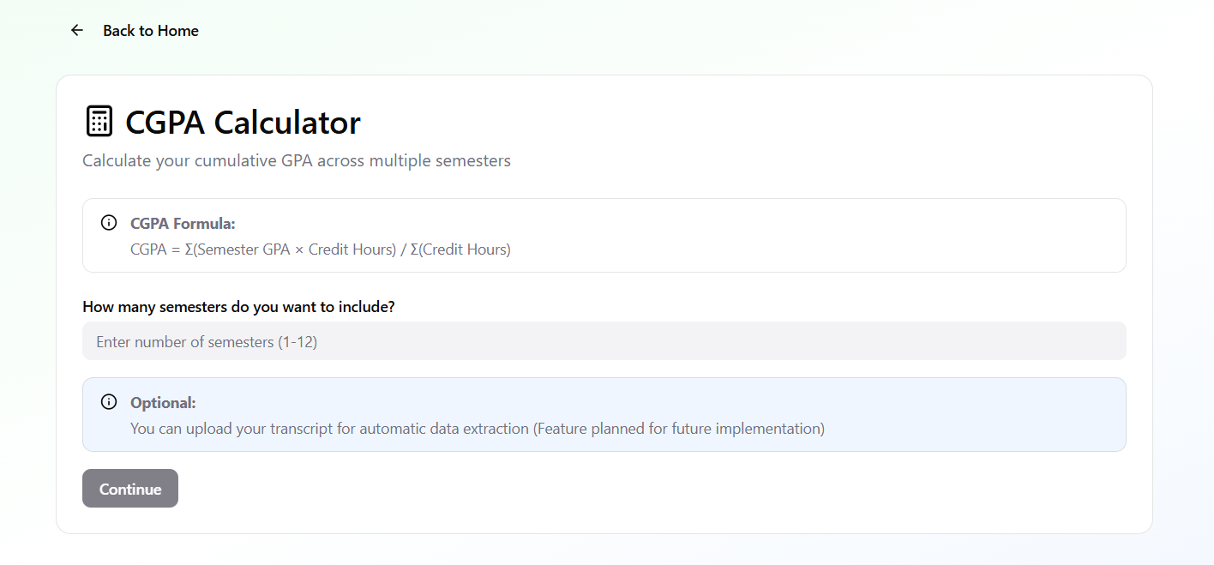

Credit Hours Explained:
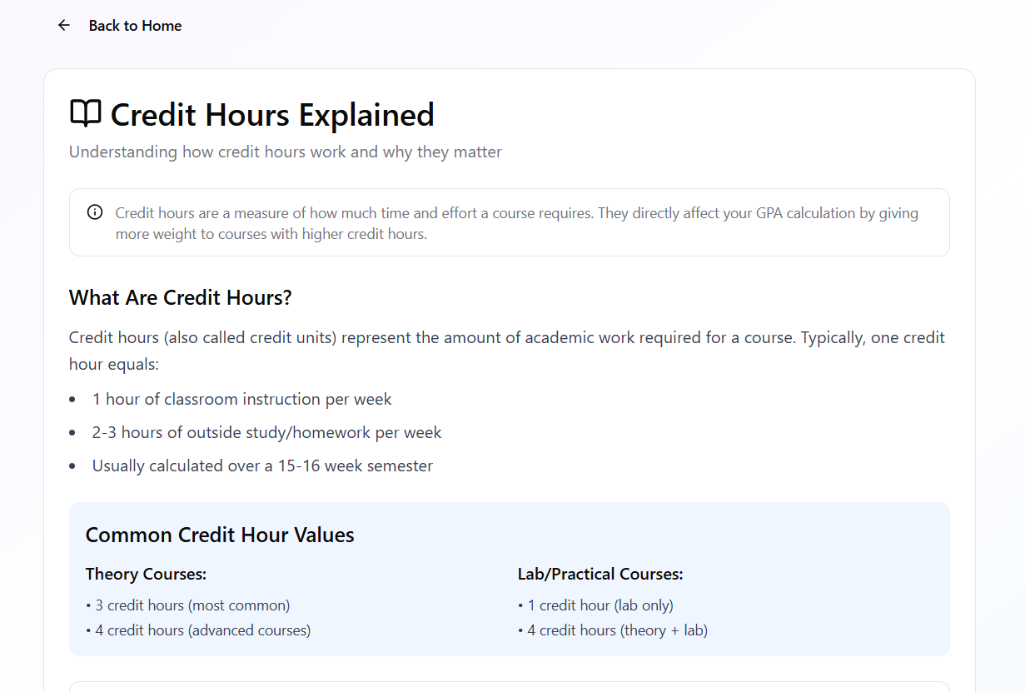
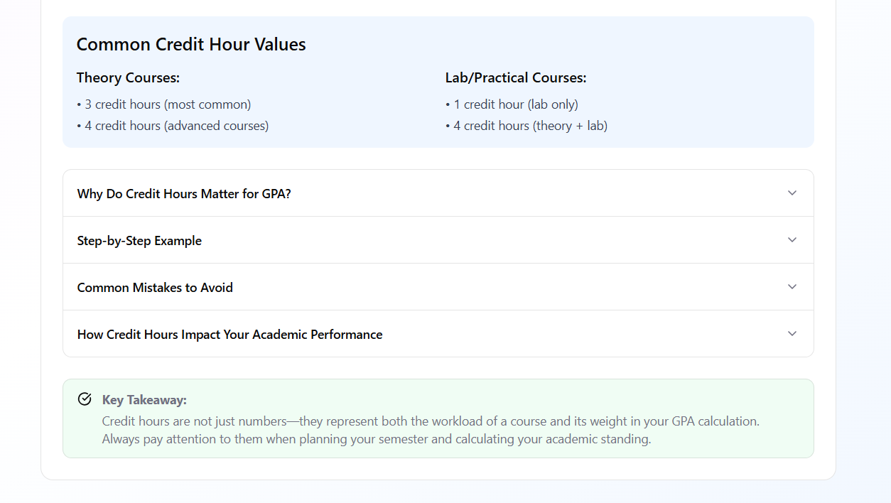

GPA & CGPA Calculation Explained:
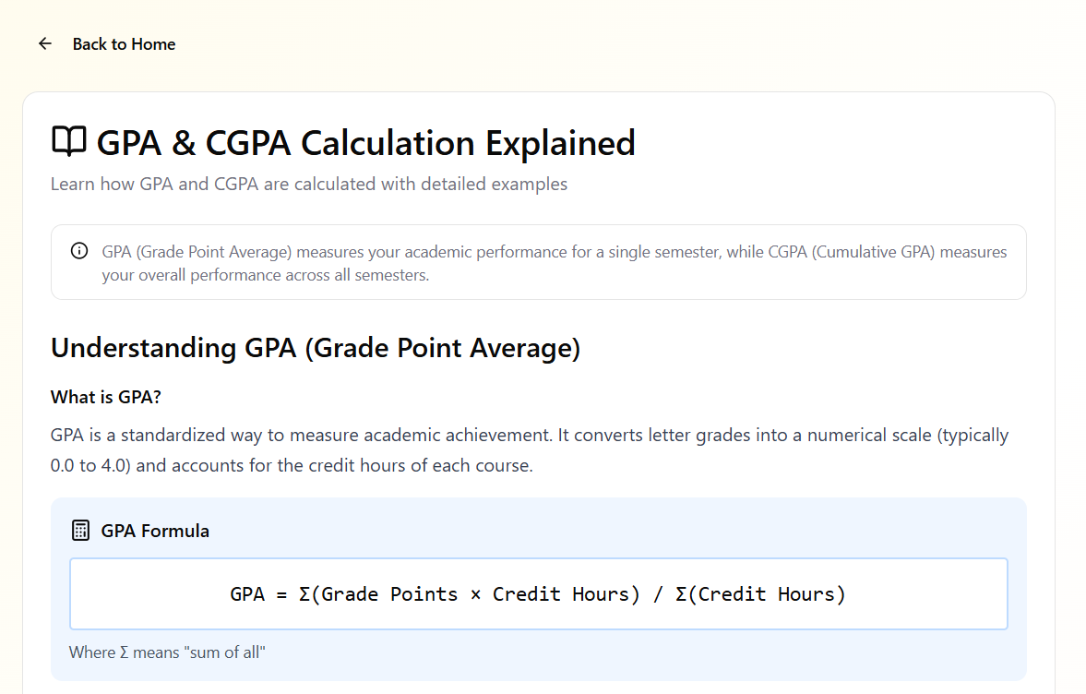
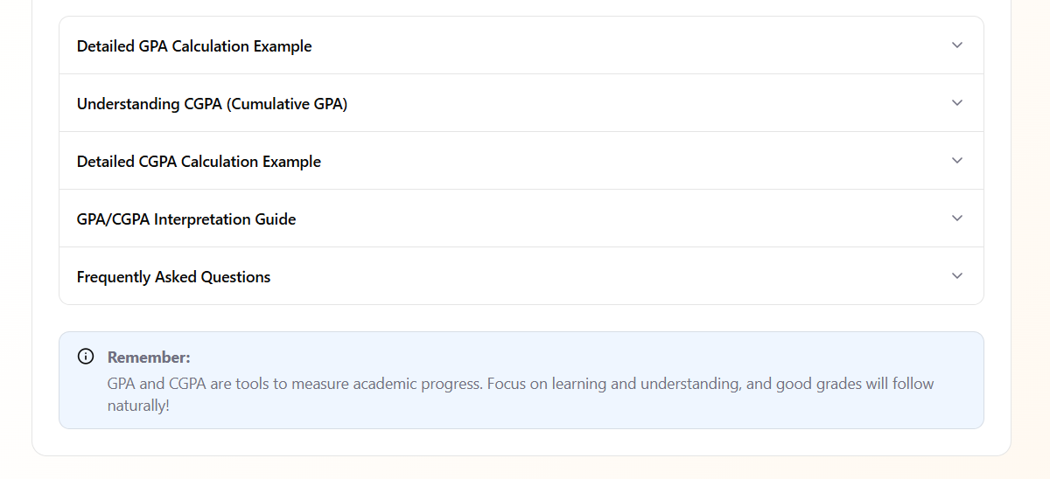

International GPA Interpretation:
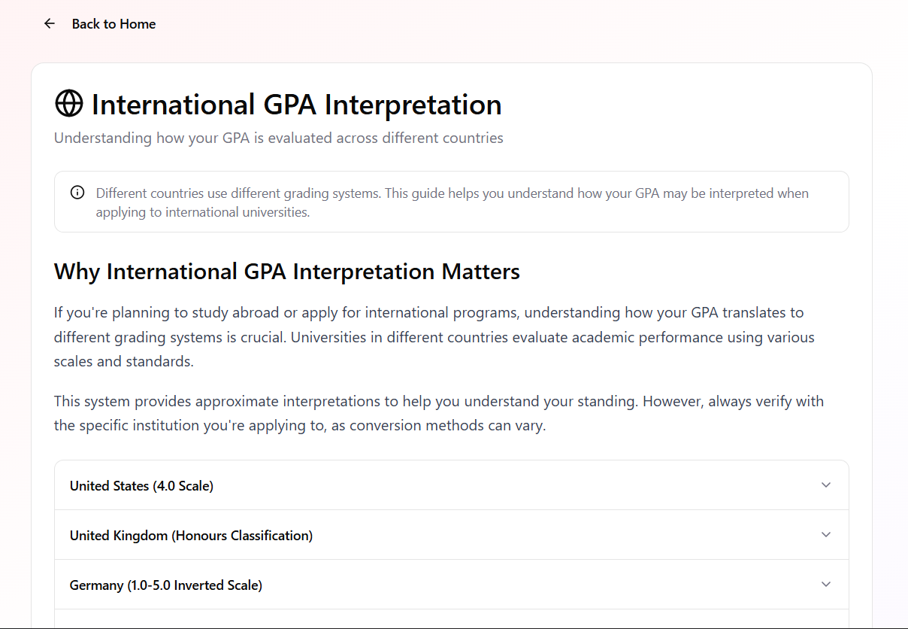
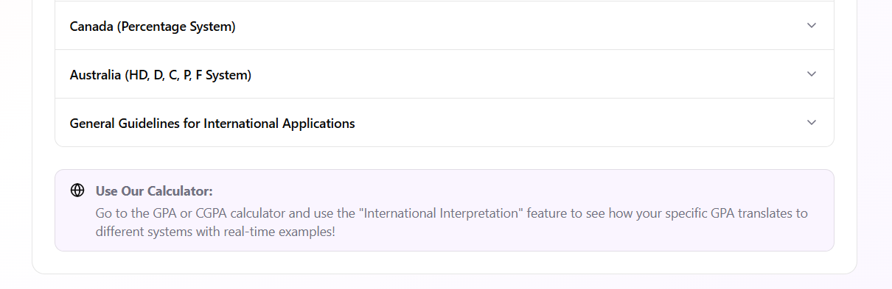

Website:
Link: https://hci-project-two-psi.vercel.app/
Desktop Interface:
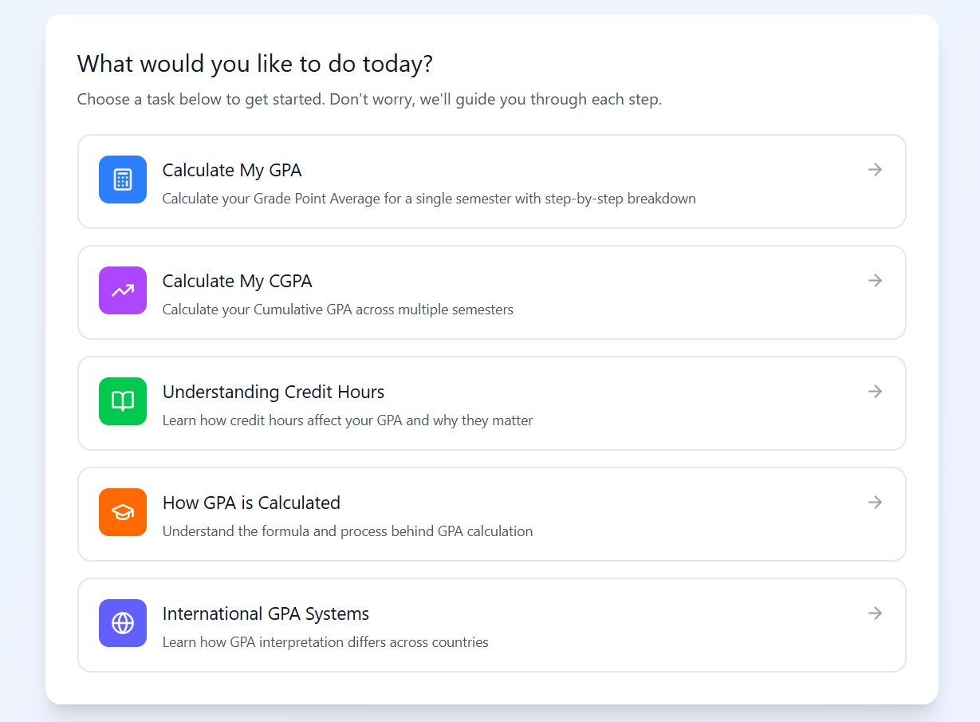
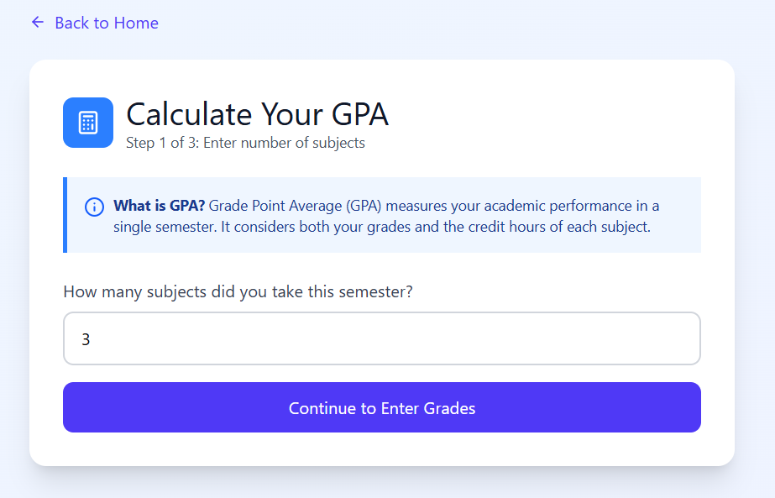
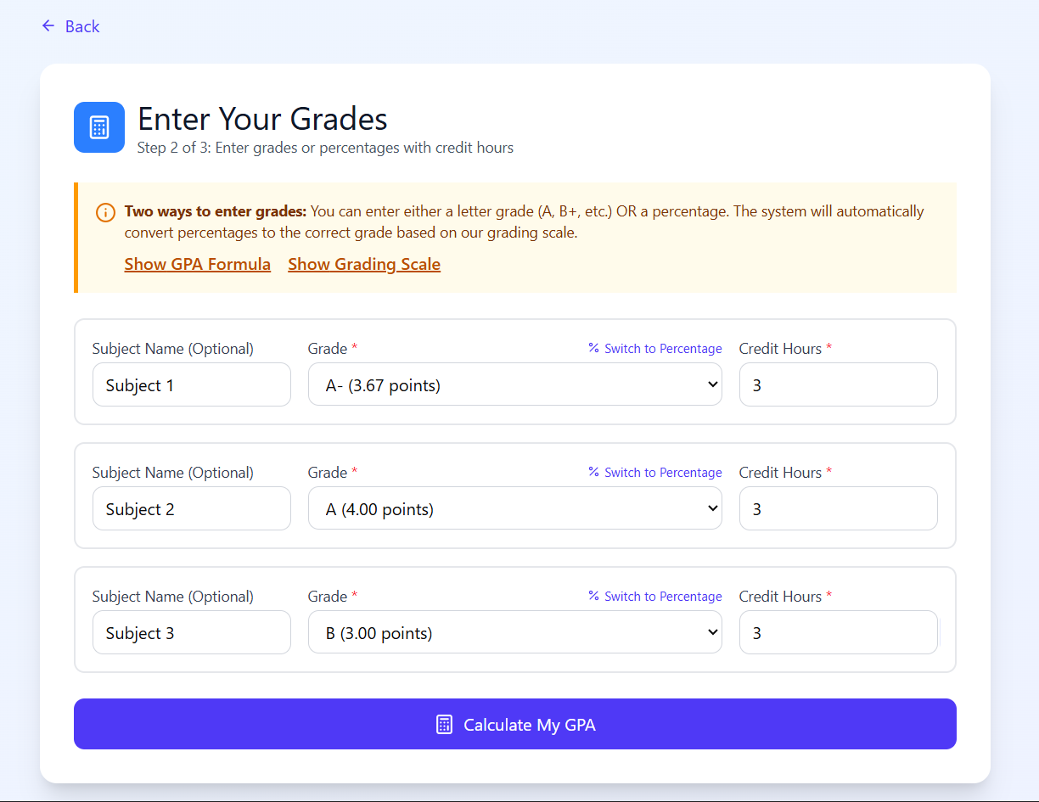
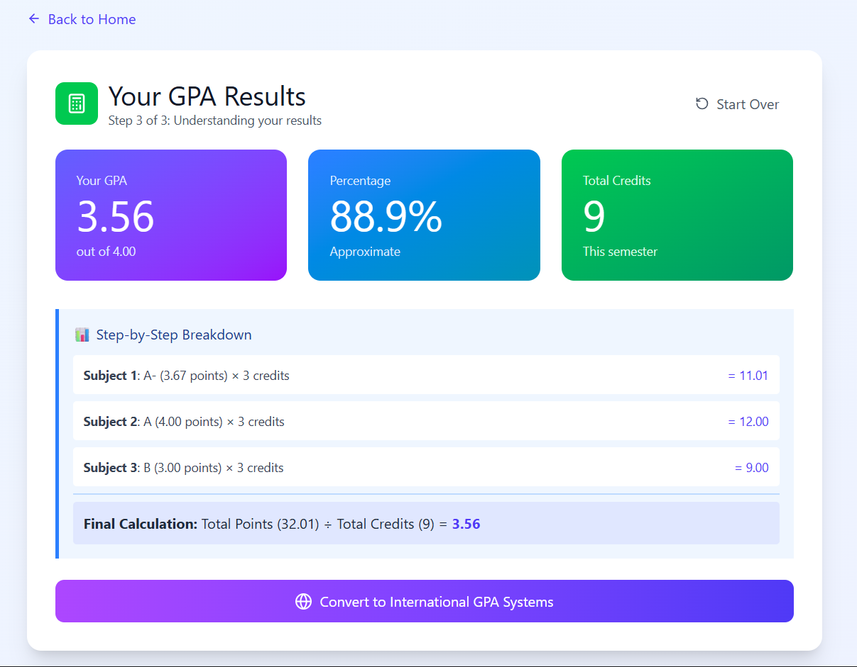

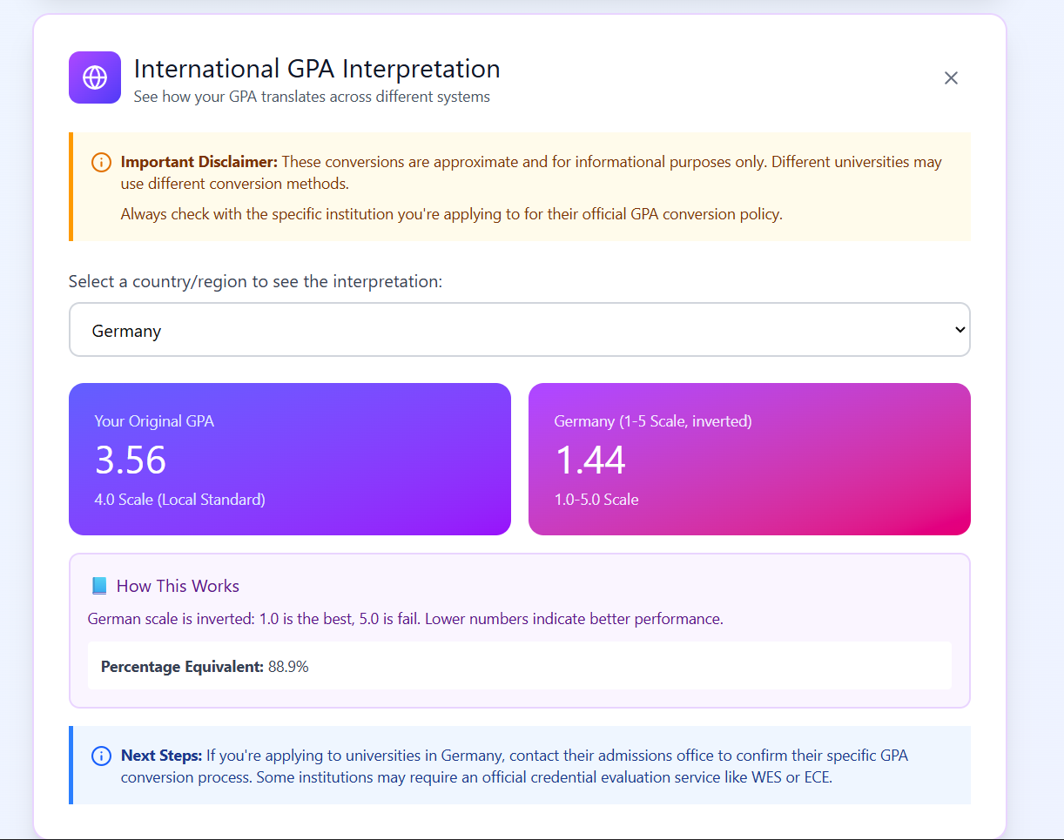
You can test the other 4 sections of the web via the link provided above :)

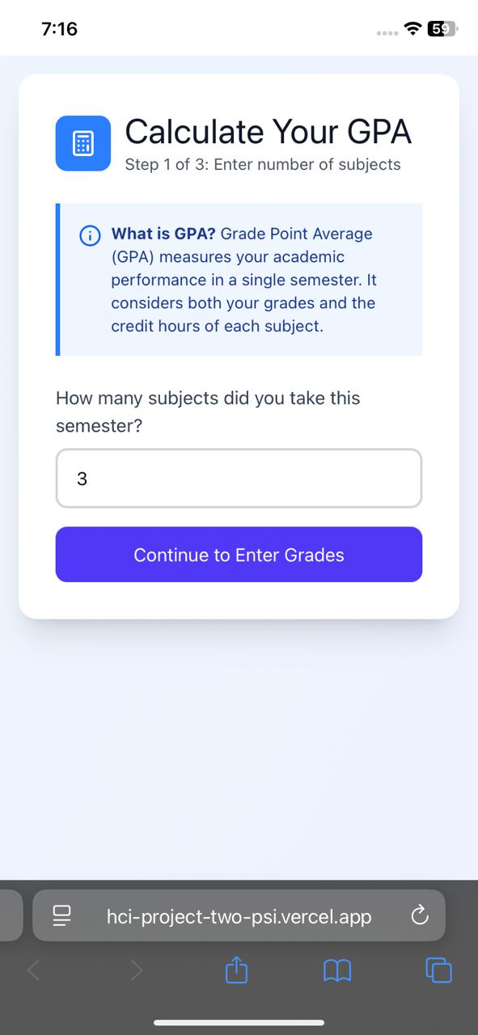
Mobile Interface:
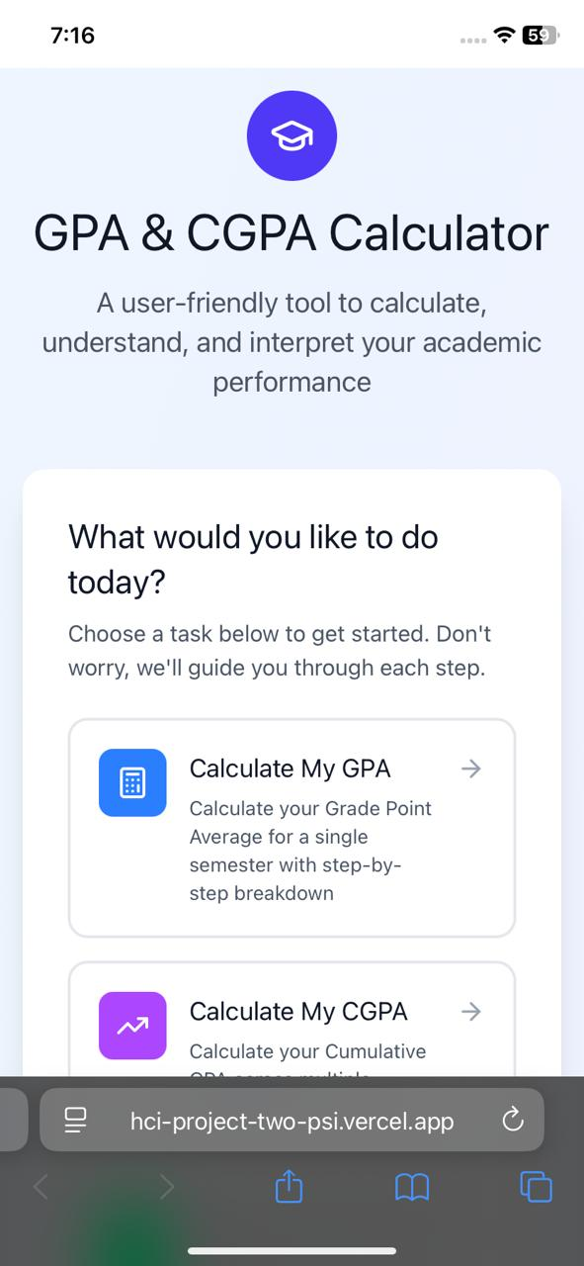

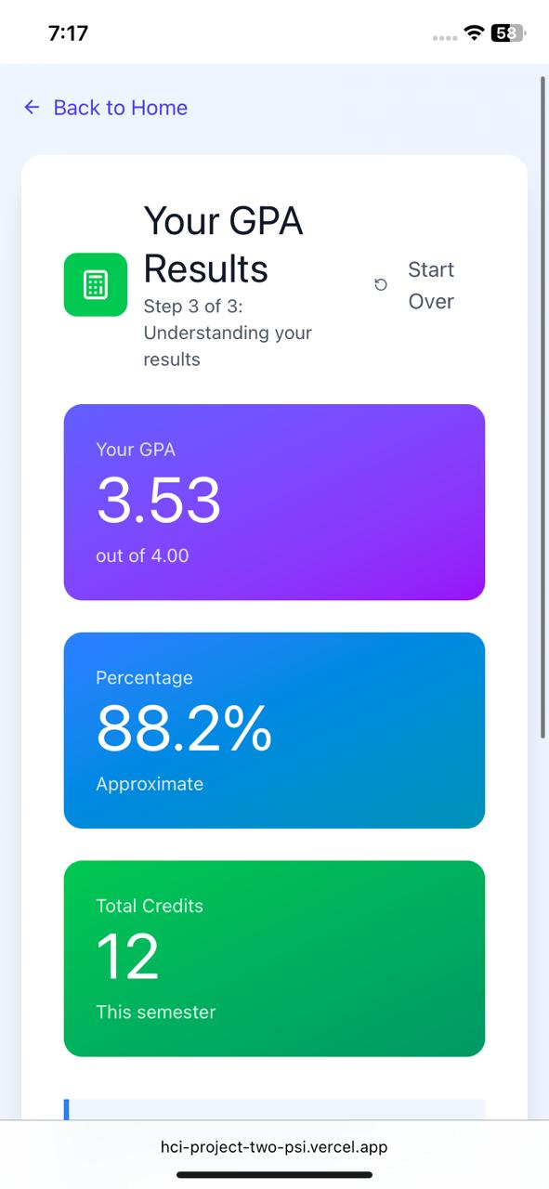
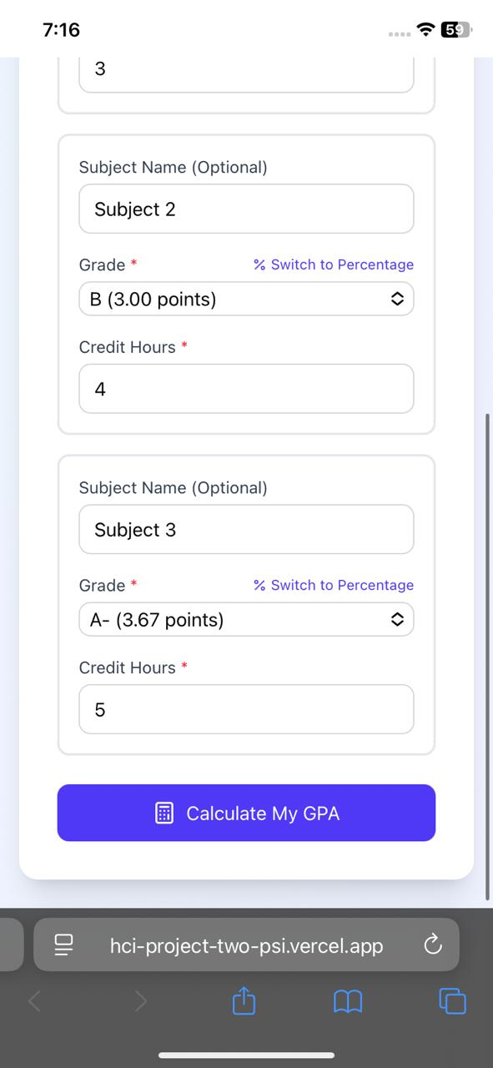

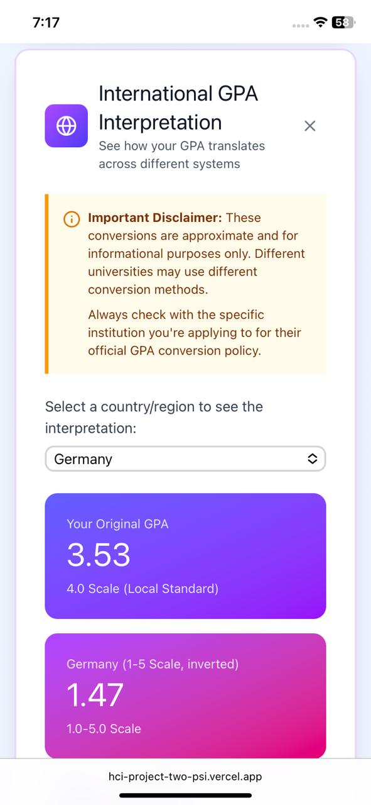
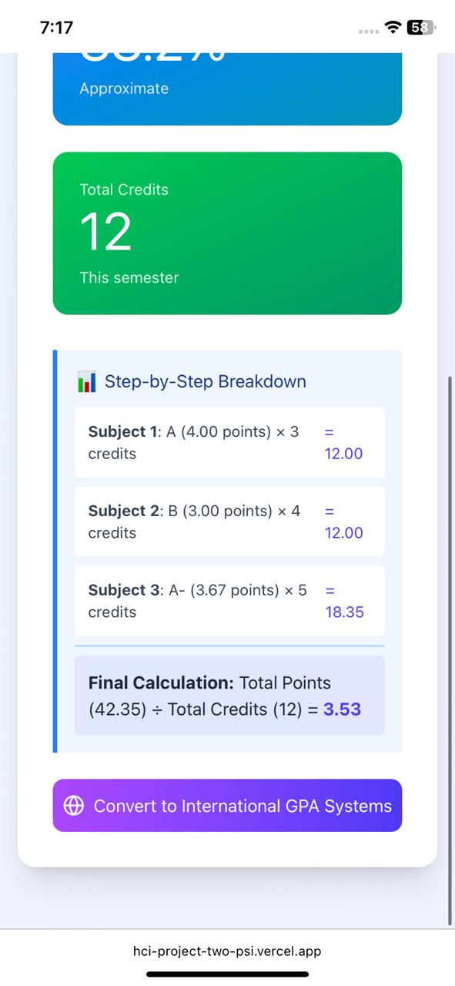

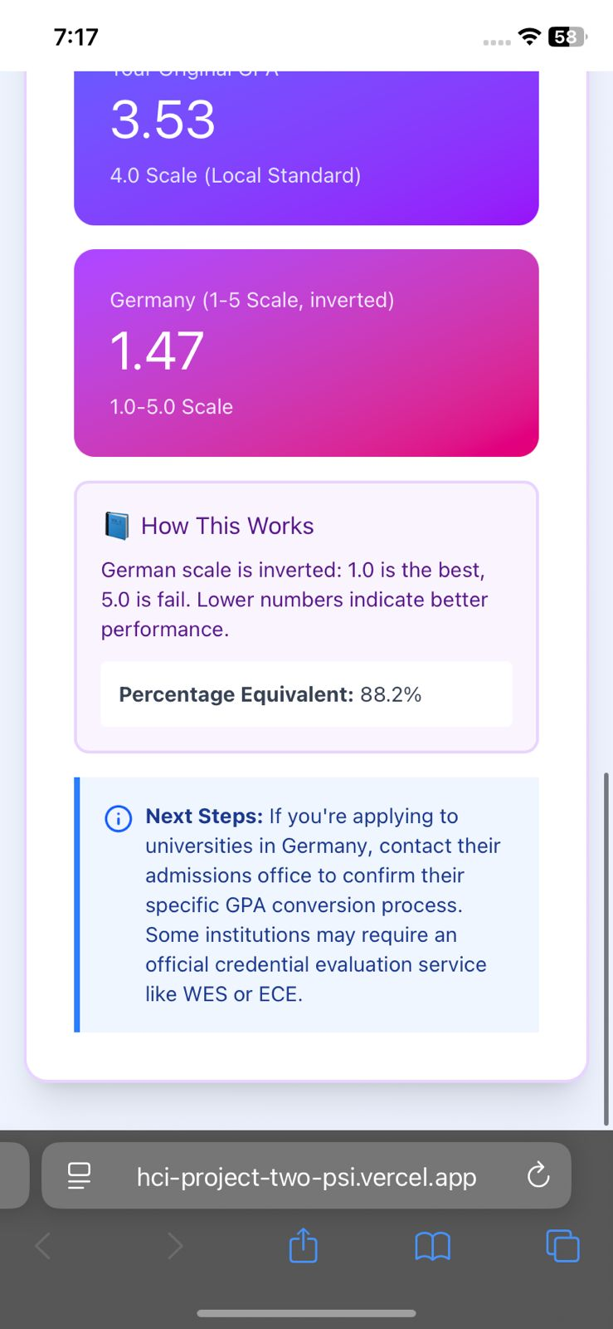
You can test the other 4 sections of the web via the link provided above :)

